**The Complete Guide to Artificial Neural Networks: Concepts and Models**

<https://missinglink.ai/guides/neural-network-concepts/complete-guide-artificial-neural-networks/>

## WHAT ARE ARTIFICIAL NEURAL NETWORKS AND DEEP NEURAL NETWORKS?

Artificial Neural Networks (ANN) is a supervised learning system built of a large number of simple elements, called neurons or perceptrons. Each neuron can make simple decisions, and feeds those decisions to other neurons, organized in interconnected layers. Together, the neural network can emulate almost any function, and answer practically any question, given enough training samples and computing power. A “shallow” neural network has only three layers of neurons:

* **An input layer** that accepts the independent variables or inputs of the model
* **One hidden layer**
* **An output layer** that generates predictions

A Deep Neural Network (DNN) has a similar structure, but it has two or more “hidden layers” of neurons that process inputs. [Goodfellow, Bengio and Courville](http://www.deeplearningbook.org/) showed that while shallow neural networks are able to tackle complex problems, deep learning networks are more accurate, and improve in accuracy as more neuron layers are added. Additional layers are useful up to a limit of 9-10, after which their predictive power starts to decline. Today most neural network models and implementations use a deep network of between 3-10 neuron layers.

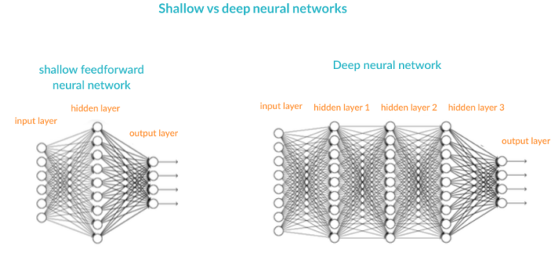

## ARTIFICIAL NEURAL NETWORK CONCEPTS

Here is a glossary of basic terms you should be familiar with before learning the details of neural networks.

### **Inputs**

Source data fed into the neural network, with the goal of making a decision or prediction about the data. Inputs to a neural network are typically a set of real values; each value is fed into one of the neurons in the input layer.

### **Training Set**

A set of inputs for which the correct outputs are known, used to train the neural network.

### **Outputs**

Neural networks generate their predictions in the form of a set of real values or boolean decisions. Each output value is generated by one of the neurons in the output layer.

### **Neuron/perceptron**

The basic unit of the neural network. Accepts an input and generates a prediction.

Each neuron accepts part of the input and passes it through the activation function. Common activation functions are sigmoid, TanH and ReLu. Activation functions help generate output values within an acceptable range, and their non-linear form is crucial for [training the network](https://missinglink.ai/guides/deep-learning-healthcare/tensorflow-resnet-building-training-scaling-residual-networks-tensorflow/" \t "_blank).

### **Weight Space**

Each neuron is given a numeric weight. The weights, together with the activation function, define each neuron’s output. Neural networks are trained by fine-tuning weights, to discover the optimal set of weights that generates the most accurate prediction.

### **Forward Pass**

The forward pass takes the inputs, passes them through the network and allows each neuron to react to a fraction of the input. Neurons generate their outputs and pass them on to the next layer, until eventually the network generates an output.

### **Error Function**

Defines how far the actual output of the current model is from the correct output. When training the model, the objective is to minimize the error function and bring output as close as possible to the correct value.

### **Backpropagation**

In order to discover the optimal weights for the neurons, we perform a backward pass, moving back from the network’s prediction to the neurons that generated that prediction. This is called backpropagation.   Backpropagation tracks the derivatives of the activation functions in each successive neuron, to find weights that brings the loss function to a minimum, which will generate the best prediction. This is a mathematical process called gradient descent.

### **Bias and Variance**

When training neural networks, like in other machine learning techniques, we try to balance between bias and variance. Bias measures how well the model fits the training set—able to correctly predict the known outputs of the training examples. Variance measures how well the model works with unknown inputs that were not available during training. Another meaning of bias is a “[bias neuron](https://missinglink.ai/guides/neural-network-concepts/neural-network-bias-bias-neuron-overfitting-underfitting/" \t "_blank)” which is used in every layer of the neural network. The bias neuron holds the number 1, and makes it possible to move the activation function up, down, left and right on the number graph.

### **Hyperparameters**

A hyperparameter is a setting that affects the structure or operation of the neural network. In real deep learning projects, tuning hyperparameters is the primary way to build a network that provides accurate predictions for a certain problem. Common hyperparameters include the number of hidden layers, the activation function, and how many times (epochs) training should be repeated.

## PERCEPTRON AND MULTILAYER PERCEPTRON – THE FOUNDATION OF THE NEURAL NETWORKS

### WHAT IS A PERCEPTRON?

A perceptron is a binary classification algorithm modeled after the functioning of the human brain—it was intended to emulate the neuron. The perceptron, while it has a simple structure, has the ability to learn and solve very complex problems.

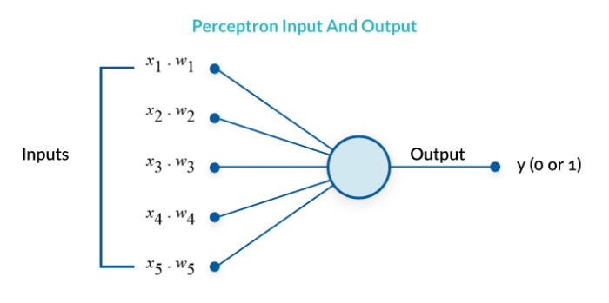

### WHAT IS A MULTILAYER PERCEPTRON?

A multilayer perceptron (MLP) is a group of perceptrons, organized in multiple layers, that can accurately answer complex questions. Each perceptron in the first layer (on the left) sends signals to all the perceptrons in the second layer, and so on. An MLP contains an input layer, at least one hidden layer, and an output layer.

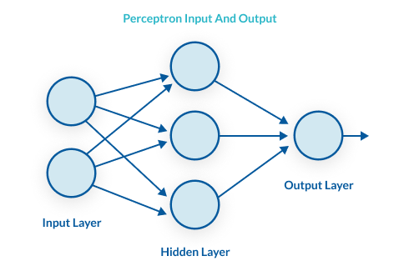

Multilayer perceptron

### THE PERCEPTRON LEARNING PROCESS

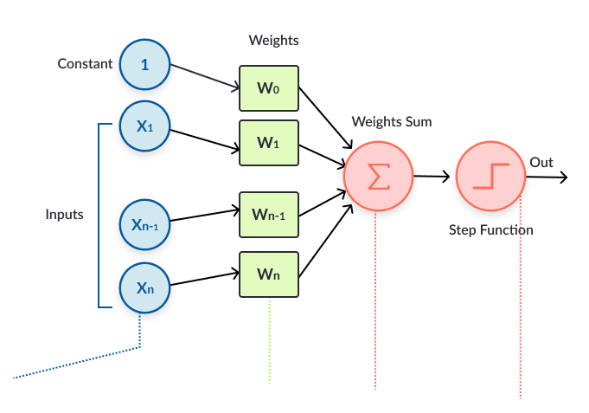

Perceptron learning process

**The perceptron learns as follows:**

1. Takes the inputs which are fed into the perceptrons in the input layer, multiplies them by their weights, and computes the sum.
2. Adds the number one, multiplied by a “bias weight”. This is a technical step that makes it possible to move the output function of each perceptron (the activation function) up, down, left and right on the number graph.
3. Feeds the sum through the activation function—in a simple perceptron system, the activation function is a step function.
4. The result of the step function is the output.

### FROM PERCEPTRON TO DEEP NEURAL NETWORK

A multilayer perceptron is quite similar to a modern neural network. By adding a few ingredients, the perceptron architecture becomes a full-fledged deep learning system:

* [**Activation functions**](https://missinglink.ai/guides/neural-network-concepts/complete-guide-artificial-neural-networks/#activation)**and other**[hyperparameters](https://missinglink.ai/guides/neural-network-concepts/complete-guide-artificial-neural-networks/" \l "hyperparams) —a full neural network uses a variety of activation functions which output real values, not boolean values like in the classic perceptron. It is more flexible in terms of other details of the learning process, such as the number of training iterations (iterations and epochs), weight initialization schemes, regularization, and so on. All these can be tuned as hyperparameters.
* [**Backpropagation**](https://missinglink.ai/guides/neural-network-concepts/complete-guide-artificial-neural-networks/#backprop)—a full neural network uses the backpropagation algorithm, to perform iterative backward passes which try to find the optimal values of perceptron weights, to generate the most accurate prediction.
* [**Advanced architectures**](https://missinglink.ai/guides/neural-network-concepts/complete-guide-artificial-neural-networks/#architectures)—full neural networks can have a variety of architectures that can help solve specific problems. A few examples are [Recurrent Neural Networks (RNN)](https://missinglink.ai/guides/neural-network-concepts/complete-guide-artificial-neural-networks/" \l "RNN), [Convolutional Neural Networks (CNN)](https://missinglink.ai/guides/neural-network-concepts/complete-guide-artificial-neural-networks/" \l "CNN), and [Generative Adversarial Networks (GAN)](https://missinglink.ai/guides/neural-network-concepts/complete-guide-artificial-neural-networks/" \l "GAN).

## UNDERSTANDING BACKPROPAGATION IN NEURAL NETWORKS

### WHAT IS BACKPROPAGATION AND WHY IS IT IMPORTANT?

After a neural network is defined with initial weights, and a forward pass is performed to generate the initial prediction, there is an error function which defines how far away the model is from the true prediction. There are many possible algorithms that can minimize the error function—for example, one could do a brute force search to find the weights that generate the smallest error. However, for large neural networks, a training algorithm is needed that is very computationally efficient. Backpropagation is that algorithm—it can discover the optimal weights relatively quickly, even for a network with millions of weights.

### HOW BACKPROPAGATION WORKS

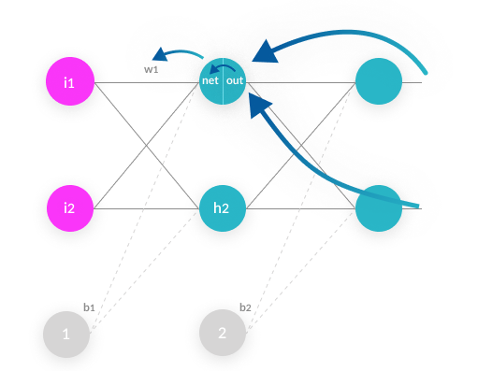

Backpropagation

1. **Forward pass**—weights are initialized and inputs from the training set are fed into the network. The forward pass is carried out and the model generates its initial prediction.
2. **Error function**—the error function is computed by checking how far away the prediction is from the known true value.
3. **Backpropagation with gradient descent**—the backpropagation algorithm calculates how much the output values are affected by each of the weights in the model. To do this, it calculates partial derivatives, going back from the error function to a specific neuron and its weight. This provides complete traceability from total errors, back to a specific weight which contributed to that error. The result of backpropagation is a set of weights that minimize the error function.
4. **Weight update**—weights can be updated after every sample in the training set, but this is usually not practical. Typically, a batch of samples is run in one big forward pass, and then backpropagation performed on the aggregate result. The batch size and number of batches used in training, called iterations, are important [hyperparameters](https://missinglink.ai/guides/neural-network-concepts/complete-guide-artificial-neural-networks/" \l "hyperparams) that are tuned to get the best results. Running the entire training set through the backpropagation process is called an epoch.

### BACKPROPAGATION IN THE REAL WORLD

In the real world, you will probably not code an implementation of backpropagation, because others have already done this for you. You can work with deep learning frameworks like [Tensorflow](https://www.tensorflow.org/) or [Keras](https://keras.io/), which contain efficient implementations of backpropagation, which you can run with only a few lines of code.

## UNDERSTANDING NEURAL NETWORK ACTIVATION FUNCTIONS

Activation functions are central to deep learning architectures. They determine the output of the model, its computational efficiency, and its ability to train and converge after multiple iterations of training.

### WHAT IS A NEURAL NETWORK ACTIVATION FUNCTION?

An activation function is a mathematical equation that determines the output of each element (perceptron or neuron) in the neural network. It takes in the input from each neuron and transforms it into an output, usually between one and zero or between -1 and one. Classic activation functions used in neural networks include the step function (which has a binary input), sigmoid and tanh. New activation functions, intended to improve computational efficiency, include ReLu and Swish.

### ROLE OF THE ACTIVATION FUNCTION

In a neural network, inputs, which are typically real values, are fed into the neurons in the network. Each neuron has a weight, and the inputs are multiplied by the weight and fed into the activation function.

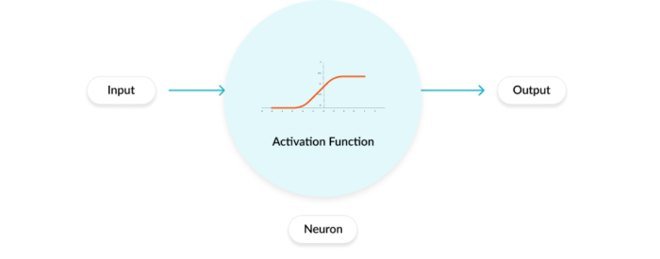

Activation function

Each neuron’s output is the input of the neurons in the next layer of the network, and so the inputs cascade through multiple activation functions until eventually, the output layer generates a prediction. Neural networks rely on nonlinear activation functions—the derivative of the activation function helps the network learn through the backpropagation process (see [backpropagation](https://missinglink.ai/guides/neural-network-concepts/complete-guide-artificial-neural-networks/" \l "backprop) above).

### 7 COMMON ACTIVATION FUNCTIONS

1. **The sigmoid function** has a smooth gradient and outputs values between zero and one. For very high or low values of the input parameters, the network can be very slow to reach a prediction, called the *vanishing gradient*problem.
2. **The TanH function** is zero-centered making it easier to model inputs that are strongly negative strongly positive or neutral.
3. **The ReLu function** is highly computationally efficient but is not able to process inputs that approach zero or negative.
4. **The Leaky ReLu** function has a small positive slope in its negative area, enabling it to process zero or negative values.
5. **The Parametric ReLu** function allows the negative slope to be learned, performing backpropagation to learn the most effective slope for zero and negative input values.
6. **Softmax** is a special activation function use for output neurons. It normalizes outputs for each class between 0 and 1, and returns the probability that the input belongs to a specific class.
7. **Swish** is a new activation function discovered by Google researchers. It performs better than ReLu with a similar level of computational efficiency.

### ACTIVATION FUNCTIONS IN THE REAL WORLD

The selection of an activation function is critical to building and training in your network. Experimenting with different activation functions will allow you to achieve better results. In real-world neural network projects, the activation function is a [hyperparameter](https://missinglink.ai/guides/neural-network-concepts/complete-guide-artificial-neural-networks/" \l "hyperparams). You can use the deep learning framework of your choice to change the activation function as you fine-tune your experiments.

## NEURAL NETWORK BIAS

In artificial neural networks, the word bias has two meanings:

* It can mean a *bias neuron*, which is part of the structure of the neural network
* It can mean *bias* as a statistical concept, which reflects how well the network is able to generate predictions based on the training samples you provide.

**The bias neuron** In each layer of the neural network, a bias neuron is added, which simply stores a value of 1. The bias neuron makes it possible to move the activation function left, right, up, or down on the number graph. Without a bias neuron, each neuron takes the input and multiplies it by its weight, without adding anything to the activation equation. This means, for example, it is not possible to input a value of zero and generate an output of two. In many cases it’s necessary to move the entire activation function to the left or to the right, upwards or downwards, to generate the required output values; the bias neuron makes this possible.

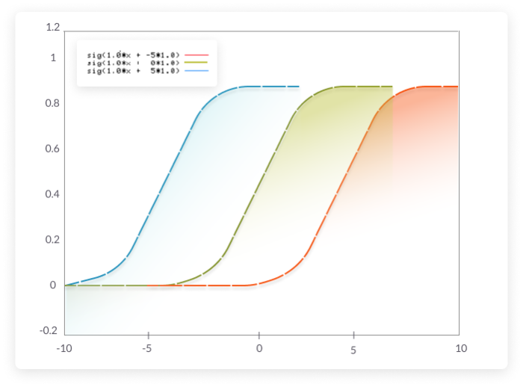

Bias on an activation function

### DEFINITION OF BIAS VS. VARIANCE IN NEURAL NETWORKS

To understand bias vs. variance, we first need to introduce the concept of a training set and validation set:

* A **training set** is a group of examples which is fed to the neural network during training.
* A **validation set** is a group of unseen examples which you use to test your neural network to see how it performs.
* An **error function** calculates the error, for either the training or validation sets. The eror reflects how far away the network’s actual predictions were compared to the known correct outputs.

**Bias** reflects how well the model fits the training set. A high bias means the neural network is not able to generate correct predictions even for the examples it trained on. **Variance**reflects how well the model fits unseen examples in the validation set.  A high variance means the neural network is not able to correctly predict for new examples it hasn’t seen before.

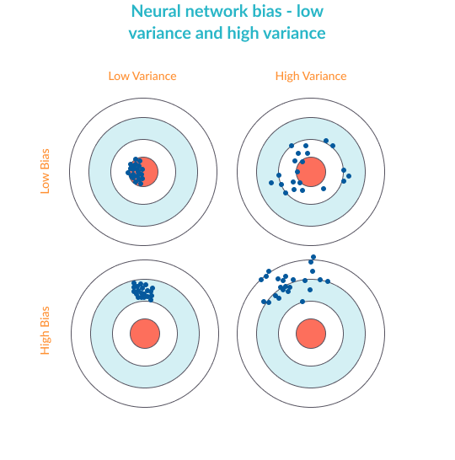

Neural network bias

### OVERFITTING AND UNDERFITTING IN NEURAL NETWORKS

**Overfitting** happens when the neural network is good at learning its training set, but is not able to generalize its predictions to additional, unseen examples. This is characterized by low bias and high variance. **Underfitting**happens when the neural network is not able to accurately predict for the training set, not to mention for the validation set. This is characterized by high bias and high variance.

### METHODS TO AVOID OVERFITTING

Here are a few common methods to avoid overfitting in neural networks:

* **Retraining neural networks**—running the same model on the same training set but with different initial weights, and selecting the network with the best performance.
* **Multiple neural networks**—training several neural network models in parallel, with the same structure but different weights, and averaging their outputs.
* **Early stopping**—training the network, monitoring the error on the validation set after each iteration, and stopping training when the network starts to overfit the data.
* **Regularization**—adding a term to the error function equation, intended to decrease the weights and biases, smooth outputs and make the network less likely to overfit.
* **Tuning performance ratio**—similar to regularization, but using a parameter that defines by how much the network should be regularized.

### METHODS TO AVOID UNDERFITTING

### **Methods to Avoid Underfitting**

Here are a few common methods to avoid underfitting in a neural network:

* **Adding neuron layers or inputs**—adding neuron layers, or increasing the number of inputs and neurons in each layer, can generate more complex predictions and improve the fit of the model.
* **Adding more training samples or improving quality**—the more training samples you feed into the network, and the better they represent the variance in the real population, the better the network will perform.
* **Dropout**—randomly “kill” a certain percentage of neurons in every training iteration. This ensures some information learned is randomly removed, reducing the risk of overfitting.
* **Decreasing regularization parameter**—regularization can be overdone. By using a regularization performance parameter, you can learn the optimal degree of regularization, which can help the model better fit the data.

## NEURAL NETWORK HYPERPARAMETERS

Hyperparameters determine how the neural network is structured, how it trains, and how its different elements function. Optimizing hyperparameters is an art: there are several ways, ranging from manual trial and error to sophisticated algorithmic methods.

### THE DIFFERENCE BEWTEEN MODEL PARAMETER AND HYPERPARAMETER

* **A model parameter** is internal to learn your network and is used to make predictions in a production deep learning model. The objective of training is to learn the values of the model parameters.
* **A** **hyperparameter** is an external parameter set by the operator of the neural network. For example, the number of iterations of training, the number of hidden layers, or the activation function. Different values of hyperparameters can have a major impact on the performance of the network.

### LIST OF COMMON HYPERPARAMETERS

|  |  |
| --- | --- |
| **Hyperparameters related to neural network structure** | **Hyperparameters related to the training algorithm** |
| * Number of hidden layers * Dropout * Activation function * Weights initialization | * Learning rate * Epoch, iterations and batch size * Optimizer algorithm * Momentum |

### 4 METHODS OF HYPERPARAMETER TUNING

In a neural network experiment, you will typically try many possible values of hyperparameters and see what works best. In order to evaluate the success of different values, retrain the network, using each set of hyperparameters, and test it against your validation set. If your training set is small, you can use **cross-validation**—dividing the training set into multiple groups, training the model on each of the groups then validating it on the other groups. Following are common methods used to tune hyperparameters:

1. **Manual hyperparameter tuning**—an experienced operator can guess parameter values that will achieve very high accuracy. This requires trial and error.
2. **Grid search**—this involves systematically testing multiple values of each hyperparameter and retraining the model for each combination.
3. **Random search**—a research study by [Bergstra and Bengio](http://www.jmlr.org/papers/volume13/bergstra12a/bergstra12a.pdf) showed that using random hyperparameter values is actually more effective than manual search or grid search.
4. **Bayesian optimization—**a method proposed by [Shahriari, et al](https://drive.google.com/viewerng/viewer?url=https://www.cs.ox.ac.uk/people/nando.defreitas/publications/BayesOptLoop.pdf), which trains the model with different hyperparameter values over and over again, and tries to observe the shape of the function generated by different parameter values. It then extends this function to predict the best possible values. This method provides higher accuracy than random search.

### HYPERPARAMETER OPTIMIZATION IN THE REAL WORLD

In a real neural network project, you can either manually optimize hyperparameter values; use optimization techniques in the deep learning framework of your choice, or use one of several third-party hyperparameter optimization tools. **If you use** **Keras**, you can use these libraries for hyperparameter optimization: [Hyperopt](https://github.com/maxpumperla/hyperas), [Kopt](https://github.com/Avsecz/kopt) and [Talos](https://github.com/autonomio/talos) **If you use TensorFlow**, you can use [GPflowOpt](https://github.com/GPflow/GPflowOpt) for bayesian optimization, and commercial solutions like Google’s [Cloud Machine Learning Engine](https://cloud.google.com/ml-engine/docs/tensorflow/using-hyperparameter-tuning) which provide multiple optimization options.

## CLASSIFICATION WITH NEURAL NETWORKS

### WHAT IS CLASSIFICATION IN MACHINE AND DEEP LEARNING?

There are numerous, highly effective classification algorithms; neural networks are just one of them. The unique strength of a neural network is its ability to dynamically create complex prediction functions, and solve classification problems in a way that emulates human thinking. For certain classification problems, neural networks can provide improved performance compared to other algorithms. However, because neural networks are more computationally intensive and more complex to set up, they may be overkill in many cases.

### TYPES OF CLASSIFICATION ALGORITHMS

To understand classification with neural networks let’s cover some other common classification algorithms. Some algorithms are binary, providing a yes/no decision, while others are multi-class, letting you classify an input into several categories.

* **Logistic regression** (binary)—analyzes a set of data points and finds the best fitting model to describe them. Easy to implement and very effective for input variables that are well known, and closely correlated with the outcome.
* **Decision tree** (multiclass)—classifies using a tree structure with if-then rules, running the input through a series of decisions until it reaches a termination condition. Able to model complex decision processes and is highly intuitive, but can easily overfit the data.
* **Random forest** (multiclass)—an ensemble of decision trees, with automatic selection of the best performing tree. Provides the strength of the decision tree algorithm without the problem of overfitting.
* **Naive Bayes classifier**(multiclass)—a probability-based classifier. Calculates the likelihood that each data point exists in each of the target categories. Simple to implement and accurate for a large set of problems, but sensitive to the set of categories selected.
* **k-Nearest neighbor**(multiclass)—classifies each data point by analyzing its nearest neighbors among the training examples. Simple to implement and understand, effective for many problems, especially those with low dimensionality. Provides lower accuracy compared to supervised algorithms, and is computationally intensive.

### NEURAL NETWORK CLASSIFICATION COMPARED TO OTHER CLASSIFICATION ALGORITHMS

Neural networks classify by passing the input values through a series of neuron layers, which perform complex transformations on the data. **Strengths:** Neural networks are very effective for high dimensionality problems, or with complex relations between variables. For example, neural networks can be used to classify and label images, audio, and video, perform sentiment analysis on text, and classify security incidents into risk categories. **Weaknesses:**Neural networks are theoretically complex, difficult to implement, requiring careful fine-tuning, and computationally intensive. Unless you’re a deep learning expert, you will usually derive more value from another classification algorithm if it can provide similar performance.

## NEURAL NETWORK ARCHITECTURE

### CONVOLUTIONAL NEURAL NETWORKS

[Convolutional Neural Networks](https://missinglink.ai/guides/neural-network-concepts/convolutional-neural-network-build-one-keras-pytorch/) (CNN) have proven very effective at tasks involving data that is closely knitted together, primarily in the field of computer vision. A CNN uses a three-dimensional structure, with three sets of neurons analyzing the three layers of a color image—red, green and blue. It analyzes an image one area at a time to identify important features.

**CNN Architecture**

The “fully connected” neural network structure, in which all neurons in one layer communicate with all the neurons in the next layer, is inefficient when it comes to analyzing large images. A CNN uses a three-dimensional structure in which neurons in one layer do not connect to all the neurons in the next layer, instead, each set of neurons analyzes a small region or “feature” of the image.

The final output of this structure is a single vector of probability scores. A CNN first performs a convolution, which involves “scanning” the image, analyzing a small part of it each time, and creating a feature map with probabilities that each feature belongs to the required class (in a simple classification example). The second step is pooling, which reduces the dimensionality of each feature while maintaining its most important information.

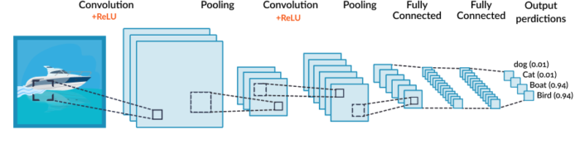

As illustrated above, a CNN can perform several rounds of convolution then pooling. Finally, when the features are at the right level of granularity, it creates a fully-connected neural network that analyzes the final probabilities and decides which class the image belongs to. The final step can also be used for more complex tasks, such as generating a caption for the image. **What can a CNN do? A few example applications:**

* [**Face recognition**](https://missinglink.ai/guides/deep-learning-frameworks/tensorflow-face-recognition-three-quick-tutorials/)
* **Identifying and classifying everyday objects in images**
* **Powering vision in robots and autonomous vehicles**
* **Recognizing scenes and suggest relevant captions**
* **Semantic parsing, sentence classification, and prediction**
* **Search query retrieval**